27.51: a) 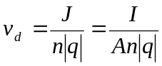
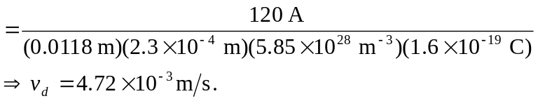

b) -direction (negative charge).
c)

